PlayGround
Test stuff here.

- Market Analysis

0.0.1 PESTEL Analysis
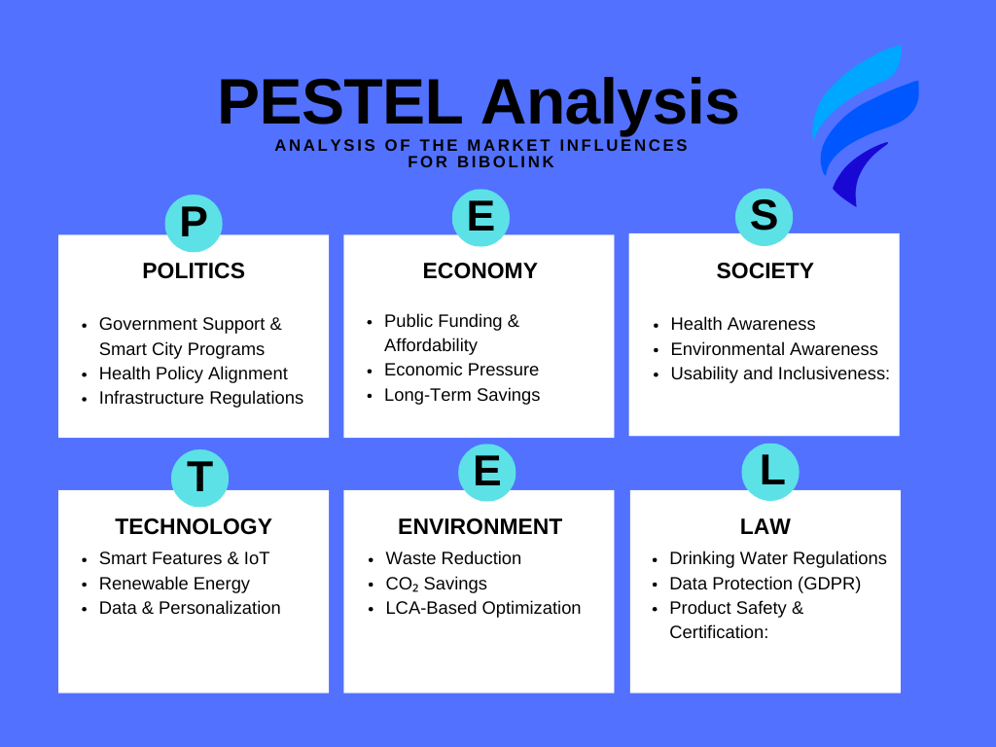

1. Political
- Government Support & Smart City Programs: Municipalities are increasingly investing in smart infrastructure and public health solutions. BiboLink fits into these strategies and could benefit from government funding or partnerships.
- Health Policy Alignment: National and local health policies that promote hydration and active lifestyles support the installation of public water dispensers.
- Infrastructure Regulations: Public installations require permits and must meet local safety and hygiene regulations, which can influence the implementation process.
2. Economic
- Public Funding & Affordability: BiboLink’s pricing must align with public budgets. Funding may come from cities, health departments, or sponsors.
- Economic Pressure: Inflation, budget cuts, or financial crises could reduce available funds for non-essential public infrastructure.
- Long-Term Savings: BiboLink can contribute to economic efficiency by reducing single-use plastic waste and supporting public health, potentially lowering long-term costs for cities.
3. Social
- Health Awareness: There is growing public interest in health, fitness, and hydration. BiboLink supports these values by making water access convenient and personalized.
- Environmental Awareness: Public concern about plastic waste is rising. BiboLink offers a sustainable alternative by encouraging refillable bottle use.
- Usability and Inclusiveness: The product must be accessible, intuitive, and suitable for all age groups, including children, the elderly, and people with disabilities.
4. Technological
- Smart Features & IoT: BiboLink integrates modern technologies like sensors, microcontrollers (e.g., ESP32), and app-based control, aligning with Smart City trends.
- Renewable Energy: The use of solar power (with optional grid backup) shows technological adaptability and eco-awareness.
- Data & Personalization: The app allows for personalized supplement dispensing and hydration tracking—but requires secure data handling.
5. Environmental
- Waste Reduction: BiboLink helps reduce single-use plastic bottles by encouraging water refill behavior.
- CO₂ Savings: Using local water and renewable energy reduces transport emissions and energy consumption.
- LCA-Based Optimization: A conducted Life Cycle Assessment (LCA) supports continuous environmental performance improvement.
6. Legal
- Drinking Water Regulations: The system must comply with EU and national drinking water safety standards.
- Data Protection (GDPR): If user data is collected via the app, all features must comply with data privacy laws.
- Product Safety & Certification: All components (e.g., electronics, valves, housing) must be CE certified and safe for public use.

0.0.2 Macro-environment

0.0.3 Micro-environment

